Analysis Using Decision Tree Classifier Model:

DOC 1: AUC_Test and Auc_Train
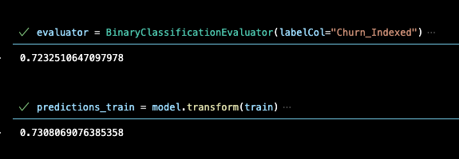
Doc:2 AUC results by attributes:
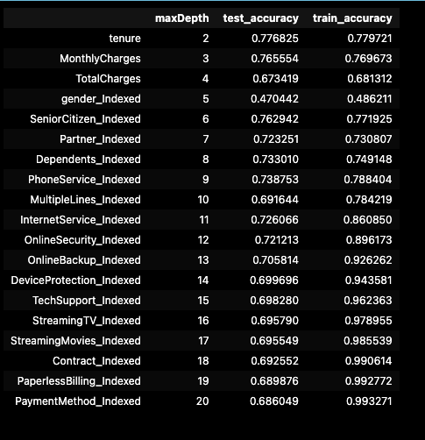

DOC3: FEATURE IMPORTANCE
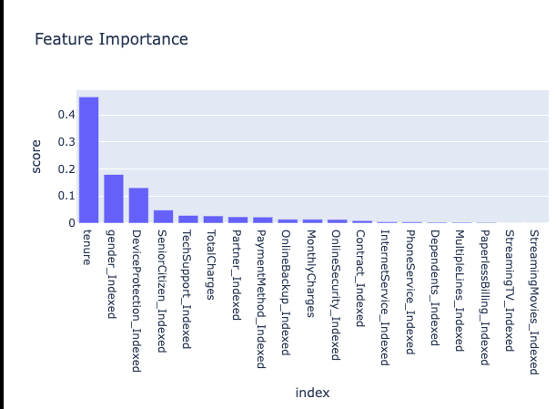

Doc4: Auc_Roc and Auc_pr
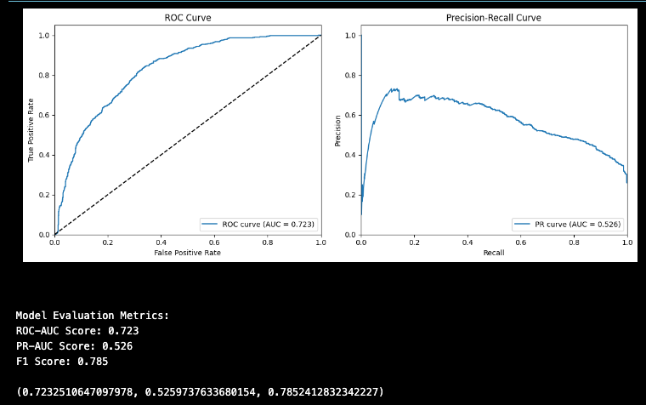

Analysis using H2o.Ai Stacked Ensemble
Doc5: Leader Board:
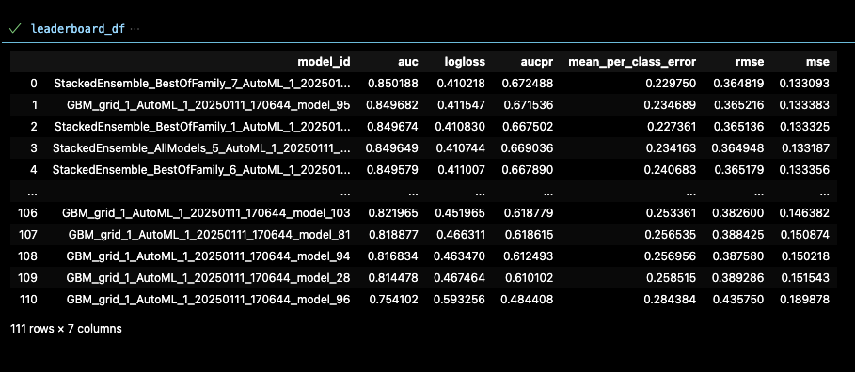

Doc6: Model Details
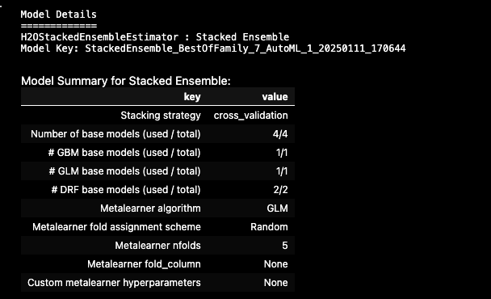

Doc 7: Model Summary of Evaluation:
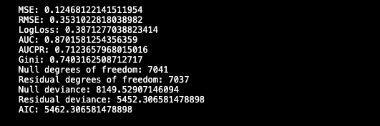

Doc 8_
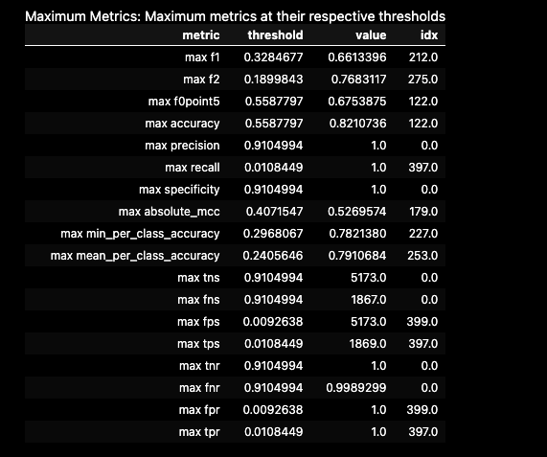

Confusion Matrix:
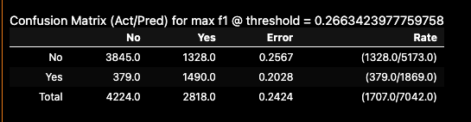

ROC
